DevOps Guide
Echo-Innovatech Environment

1. Repository structure
The entire environment is defined as code in a single version-controlled repository:
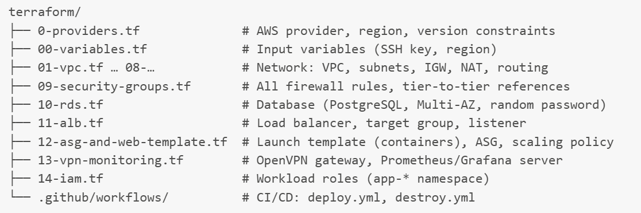
Numbered files reflect creation order and dependency flow: network → security → services.

2. The deployment pipeline
Trigger: every push to main.
Flow: GitHub → self-hosted runner (vSphere VM, systemd service) → OIDC token exchange (no stored credentials) → assumed role app-github-deployer (trust policy restricted to this repo + branch; permissions scoped to infrastructure + app-* IAM namespace) → Terraform init/plan/apply against AWS.
[SCREENSHOT: Actions run — expanded steps showing checkout, OIDC whoami output, terraform apply]
State is kept in a persistent directory on the runner VM (/home/student/tf/echo-innovatech), documented as a POC decision; the production upgrade path (S3 backend + DynamoDB lock) is documented in the Technology Justification.

3. How to make an infrastructure change
- Edit the relevant .tf file (e.g., change instance_type in 12-asg-and-web-template.tf)
- Commit + push to main
- The pipeline runs automatically: review the terraform plan output in the Actions log
- apply runs with -auto-approve (POC decision — a manual approval gate is the production recommendation)
- Instance-level changes roll out via the ASG's health-checked replacement (zero downtime)
Destroy: Actions → destroy workflow → Run workflow (manual trigger). Partial failures (Dependency Violation) have a documented cleanup procedure in the Test Plan, section 7.

4. Monitoring & alerting assets
- Grafana dashboard (per-instance comparison panels) — exported JSON in Files for grafana/dashboard.json, re-importable after every environment rebuild
- Alert rules (target-down, CPU, memory → Discord webhook) — exported JSON in Files for grafana/alerts.json
- Re-import procedure: Grafana → Dashboards → Import → upload JSON → select the Prometheus datasource

5. Post-rebuild manual steps (deliberately minimal)
Only two manual actions exist after a full pipeline rebuild, both documented step-by-step in the Operations Manual: re-issuing the OpenVPN client certificate (fresh PKI per build) and re-adding the Grafana data source (fresh container volume). Everything else — application, seeding, discovery, scaling, alerting — restores automatically.
6. Security model summary
Plane | Access | Credentials
Human → infrastructure | OpenVPN gateway (cert-based) | Client certificates from private CA
Pipeline → AWS | OIDC federation | Short-lived tokens, repo+branch conditioned
Pipeline → IAM | Scoped to app-* namespace | Guardrail enforced by policy (tested)
Services → services | Security-group references | No CIDR-wide access between tiers

